Documenting Scanning process for Nipsco

Description of Service Cards and scanning process

Each office will have multiple cabinets; Each Cabinet will have multiple Drawer; Each Drawers will have service Cards by the Street Numbers. Some of the Service Cards will be stapled which needs to be taken out before putting it in a scanner. Once the scanning is completed, the service cards will be stapled back and put at the exact location of the cabinet.
Our scanner is capable of scanning multiple service cards together. However, operator needs to make sure that all the cards are scanned properly by looking at the count and observing the monitor during scanning. Once scanned, all the documents need to go to a specific directory for uploading to our server as a separate process.

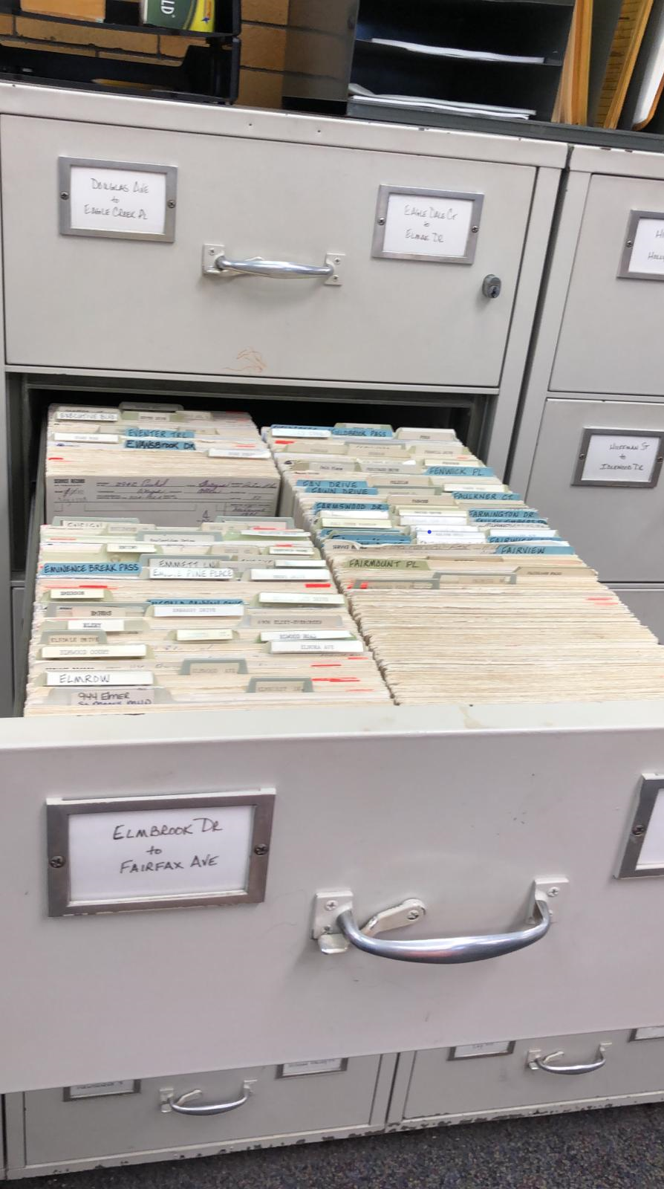
Typical Cabinet with Cards

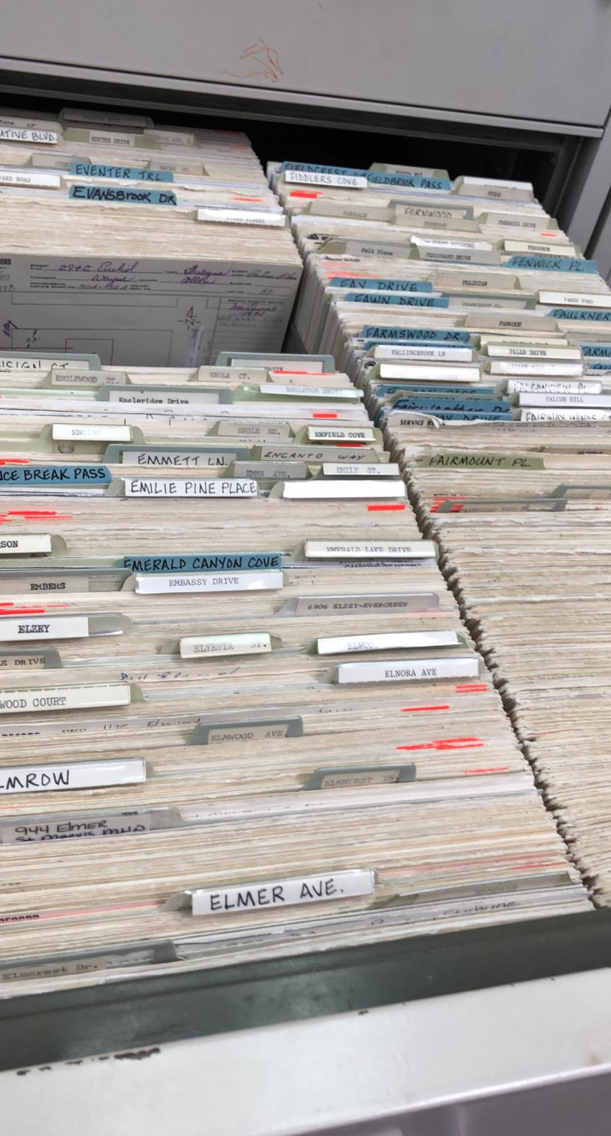
Service Cards inside a Cabinet

Selecting the Cards and Scanning

Remove any staples or paper clips from the papers in the drawer. It is demonstrated below in a picture and a video.

Each structure is a cabinet for us.
Each drawer side has approximately 1200 cards
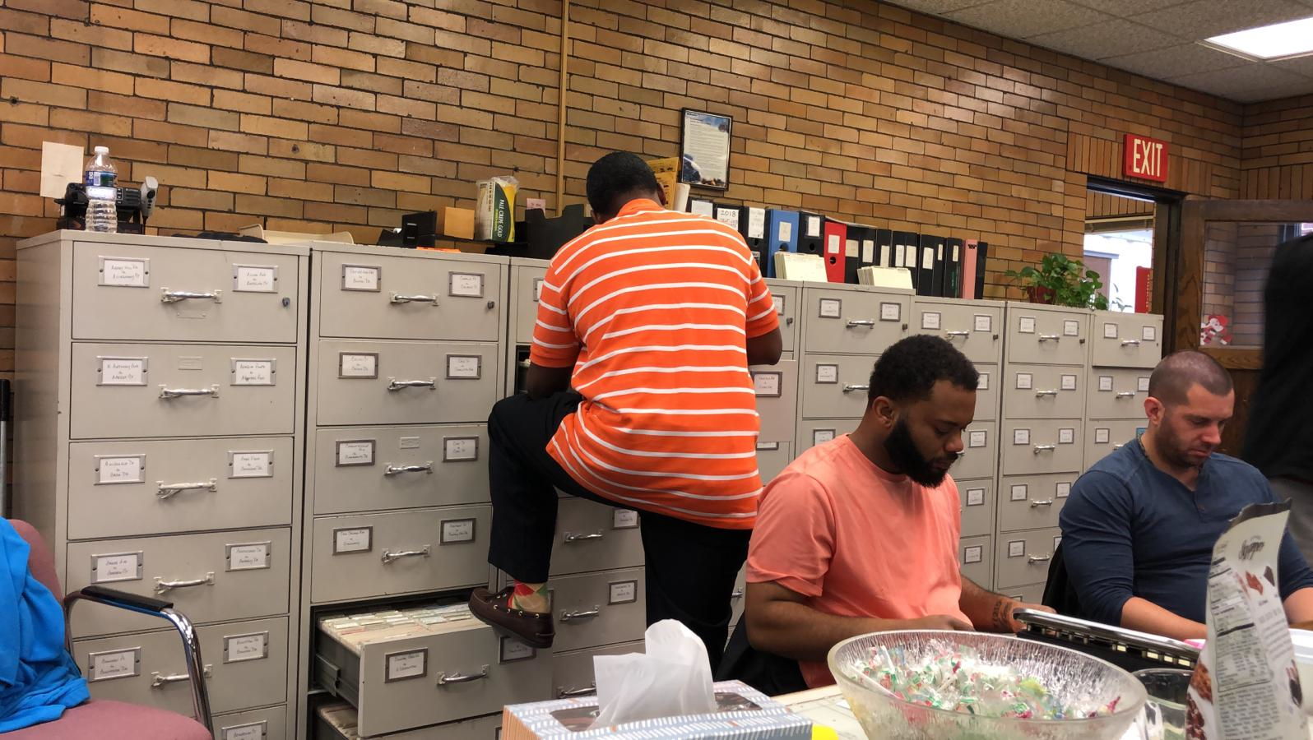
A typical cabinet structure
We take a stack at a time and remove the street markers out. Following Video illustrates this.
Then we remove staples. Please see the attached video.
At this stage, we check if a drawer is defined in our system; if not we create it. All our scanned images will be stored in this directory. After the batch is scanned, they load more or fix the orientation of the cards if required.
This is how a typical scanning operation looks like

Before starting the scanning process, we also need to make sure that the cards are put on the scanner in the correct order and the scanning count is reset to zero.
After scanning is done, the scanner displays the count and it needs to be verified manually.

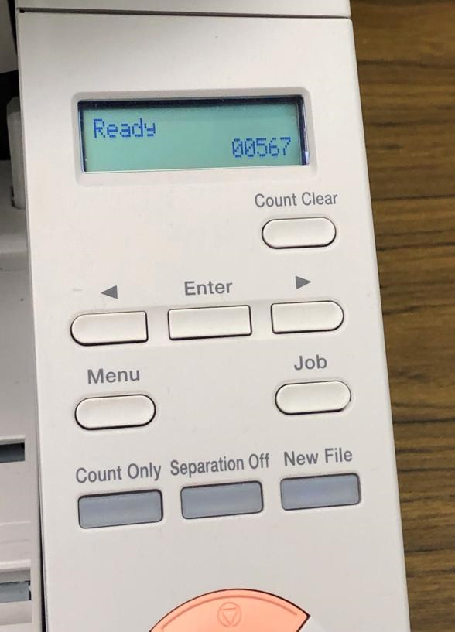
If the count matches, then it is good to go. We verify the same using following screen.

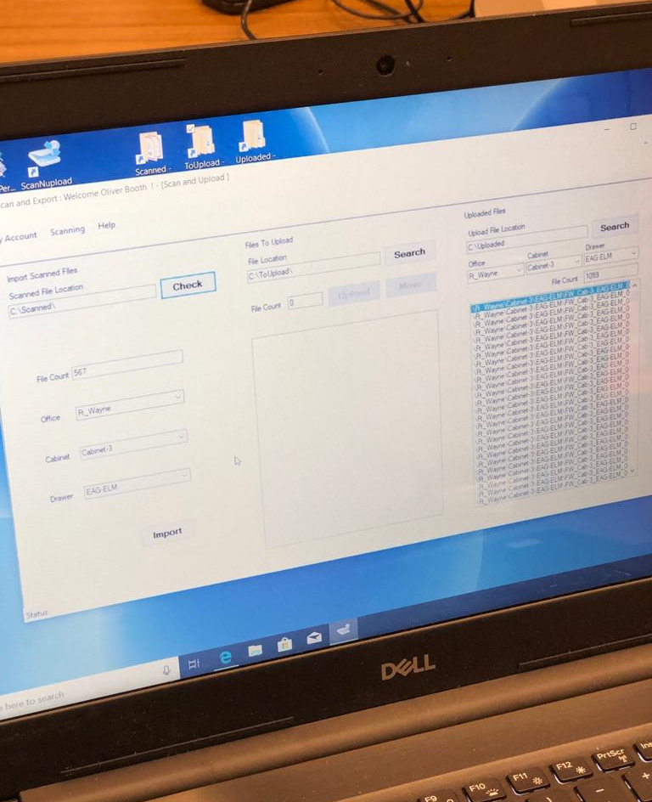

The scanning is done street wise. That’s why they put colour so that they can know which ones to staple back. We are marking cards so that we can trace back the scanned cards which may have issues.

The attached video inspects all cards after they are scanned. They also fix the orientation of the card if necessary before clearing them.

At the office at onsite, we further look at the card two times as a part of the QA process. This way we make sure that the cards are scanned properly. If still there is an orientation issue, it can be fixed at this stage as appropriate. Our checking process will ensure that all the cards are legible before they leave the scanning areas.
Putting the cards back in the drawer after Scanning

Once the scanning of a set of cards is successfully done, they need to be put back in their respective places in the same order. Some of the cards also need to be stapled back so that it goes back to its original position. We have already taken care and marked this before scanning which will help us to put it back in its position.

Following video displays this process.

