Service Card Project
Specifications
For
Northern Indiana Public Service Company


September 16, 2019

Table of Contents
2.0 Document Control 5
Updated Service Length 6
Updated Service Riser Type 6
3.0 Document Sources 7
3.1 Examples of Document Sources 7
4.0 Supporting Information 8
• Customer Referrals: 8
4.1 QUESTION (CUSTOMER REFERRAL) Situations 8
5.1.3 Service Card Symbols on sketches 9
5.1.3 NIPSCO Terminology 15
6.0 Index Definitions 15
6.1 Index Data: 15
Date Format Standards 17
Hour Format Standards 17
6.2 Universal Assumptions: 17
6.3 Data not to be captured: 17
6.4 Index Data Captured: 17
6.4.0 General Workflow 18
6.4.1 ADDRESS _NUMBER 21
6.4.2 APARTMENT NUMBER 21
6.4.2 CROSS STREETS 22
6.4.2 BUSINESS NAME 22
6.4.3 CABINET NUMBER 22
6.4.4 City 22
6.4.5 Comments 23
6.4.6 County 23
6.4.7 Development 26
6.4.8 EFV 26
6.4.9 Grid Number 26
6.4.10 Lot Number 27
6.4.11 Material 27
6.4.12 Local Operating Area 28
6.4.13.0 Main size 29
6.4.13.1 Main Material 29
6.4.13.2 Pipe size 30
6.4.14 Regulator Install Date 30
6.4.15 Retire Date 31
6.4.16 Service Riser Type 31
6.4.17 Rural Route 31
6.4.18 Service Type Code 32
6.4.19 Service Length 32
6.4.20 Service Number/ Site ID 32
6.4.21 Service Sketch 33
6.4.22 Street Suffix 34
6.4.23 Street Direction 34
6.4.24 Street Fraction 34
6.4.25 Street Name 35
6.4.26 Stub 35
6.4.27 Suite 37
6.4.28 Subdivision 37
6.4.29 Tax District 37
6.4.30 Township 37
6.4.31 Zip Code 37
6.4.32 Install Date 38
6.5 NIPSCO Standards for Gas Network: 38
6.5.1 Standard Pipe Sizes for Gas Main and Service Line 38
10.0 Appendices 41
10.0.1 Postal Service Standard Suffix Abbreviation 41
10.0.1 42
10.0.2 Tax District 42
10.0.3 Townships 42
10.0.4 Campus (Hospital, School, Industrial, etc) 42
11.0 Retired Cards 43
11.0.1 How to index a Fully Retired Service 43
12.0 Do Not Send a Referral to NIPSCO in the Following Scenarios 43

NIPSCO has defined Local Operating Areas, commonly called LOA. These LOAs once operated independently of each other. While some Service Card standards are companywide, there are some standards followed within each LOA and they may or may not be documented. Each time work starts in an area new to the Service Card team, there will likely be new practices used to record service installations or other work that will need to be reviewed. It is understood that the number of questions from Woolpert for the first batch of cards indexed of the LOA will increase. LOAs are defined in the GIS as follows:

010 = Hammond
030 = Crown Point
050 = Valparaiso
060 = South Bend
070 = Plymouth
090 = Angola
100 = Monticello
110 = Goshen
150 = Gary
160 = La Porte
180 = Peru (aka Wabash Valley)
220 = Fort Wayne

The Service Card team should do a Pre-Assessment of each LOA prior to beginning the Service Card process and clarify with NIPSCO any new practices for records management or unknown standards.

2.0 Document Control
This Specification Document is a live document that will need to be updated periodically throughout the Service Card Project. The document will be delivered with each delivery although not all deliveries will have updates. Changes will be listed in this document’s revision history. NIPSCO will approve, reject, or further modify changes during the Delivery Review process and return the document back to the Service Card team. Any back maintenance related to changes in this document will be completed internally at NIPSCO.

The following section identifies who is to receive new releases of this manual and it documents the revision history of the document.

Distribution List
Name | Approver | Organization
Kim Turner | X | NIPSCO
NIPSCO QA Team Lead | X | NIPSCO
Palash Dash | X | Pinnacle
Doug Garvey | X | Woolpert
James Overton | X | Woolpert

Revision History
Version | Date | Comments
1.0 | 9/11/2019 | Draft Version of the Service Card Specification as a template for the Service Card Team to complete- Dennis H.
1.1 | 11/14/2019 | Added source system examples and descriptions. Dennis H.
1.2 | 1/7/2020 | GDIP Update in “Material” section
1.2.1 | 1/8/2020 | Added 5/8” Plastic material determination in “Material” section
1.2.2 | 1/9/2020 | Retire Date update – When service is still active
1.2.3 | 1/13/202 | Service Length and Stub updates
1.2.4 | 1/17/20 | Updated Material type for Iron
1.2.5 | 1/21/20 | Verbiage and formatting updates
1.2.6 | 1/24/20 | Added section on Cross Streets and updated Service Length section
1.2.7 | 1/28/20 | Added 1 1/8” and ¾” and 1 1/4” material type defaults – Dennis H.
1.2.8 | 2/14/20 | Updated / added clarification for GDIP verbiage so it does not conflict with Material section
1.2.9 | 6/26/20 | Updated Service Length
1.3.0 | 6/29/20 | Updated Service Riser Type
1.3.1 | 7/8/20 | Added Main Size & Main Material
1.3.2 | 8/25/20 | Updates to the following sections: 6.4.1; 6.4.7; 6.4.11; 6.4.13; 6.4.13.1; 6.4.19; 6.4.31; 6.5.1. Added 11.0, 12.0

3.0 Document Sources
It is assumed that information to be captured from sources is in legible handwriting.
Following are the list of digital data and scanned paper sources used for the mining of facilities for this project:

- Service Cards
  - Paper source document containing service installation and maintenance information as recorded by NIPSCO
- CIS
  - Digital source for NIPSCO customer information

- Maximo
  - NIPSCO’s work order management system
- GIS
  - ESRI platform version 10.1 SP1 w/QIP and includes Schneider’s ArcFM 10.1
  - Current data model is based on the common gas distribution model of 2004/2006, extended to support NIPSCO business and technical needs.
- USPS Postal Address Standards
  - A standardized address is one that is fully spelled out, or abbreviated by using the Postal Service standard abbreviations (as shown in the standards downloaded from the Postal Service), and uses the proper format for the address style (shown in the USPS publication).

3.1 Examples of Document Sources
- Service Cards

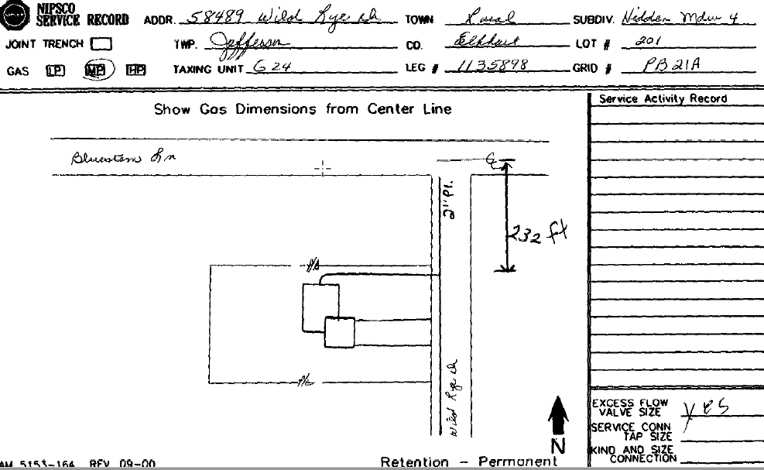

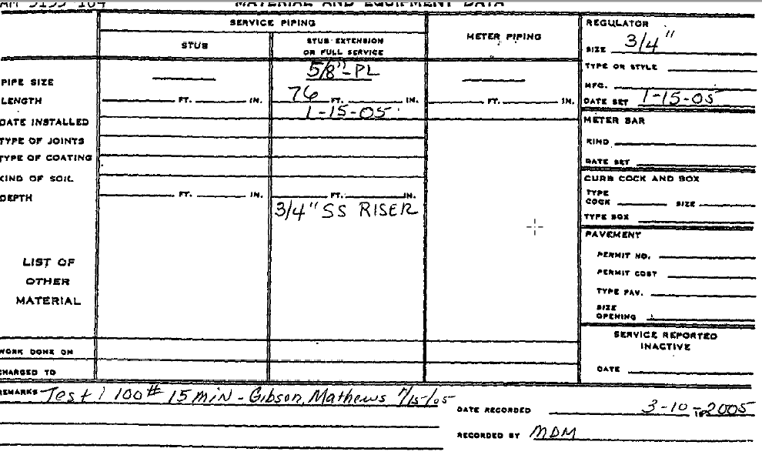

- GIS Examples
- Maximo Examples
- CIS Examples
- USPS Examples

4.0 Supporting Information
- Woolpert will make effort to try to minimize the number of service card questions (Customer referral) by including as many issues in one QUESTION (CUSTOMER REFERRAL) as possible, using the Description field.

- Customer Referrals: will be used to flag questions and issues that arise during indexing of a Service Card. When an indexing rules does not apply, the Woolpert Service Card Team will send a QUESTION (CUSTOMER REFERRAL) when a discrepancy between the source data occurs, clarification of source information is needed. Questions (Customer referral) can also be generated for missing or corrupt source information.

- NIPSCO will begin a response with “Global Rule:” when a response can be applied to all future cases. If NIPSCO does not say “Global Rule”, the response will be treated as an anomaly and applied only to those features listed in the description.

The following section details specific requirements requiring a QUESTION (CUSTOMER REFERRAL).

4.1 QUESTION (CUSTOMER REFERRAL) Situations

5.1.3 Service Card Symbols on sketches

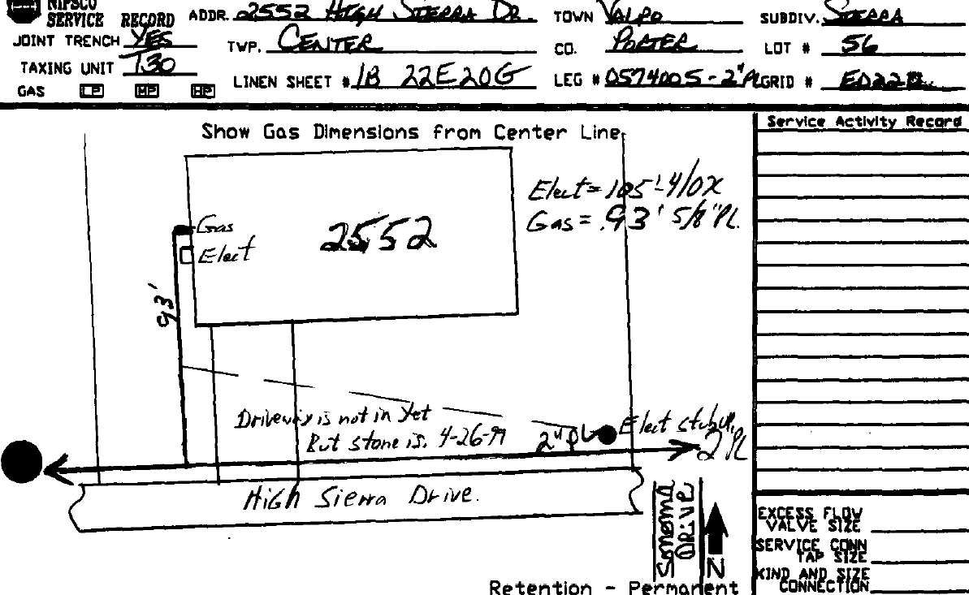
NIPSCO Gas facility objects as placed in Esri.
GIS Simbology

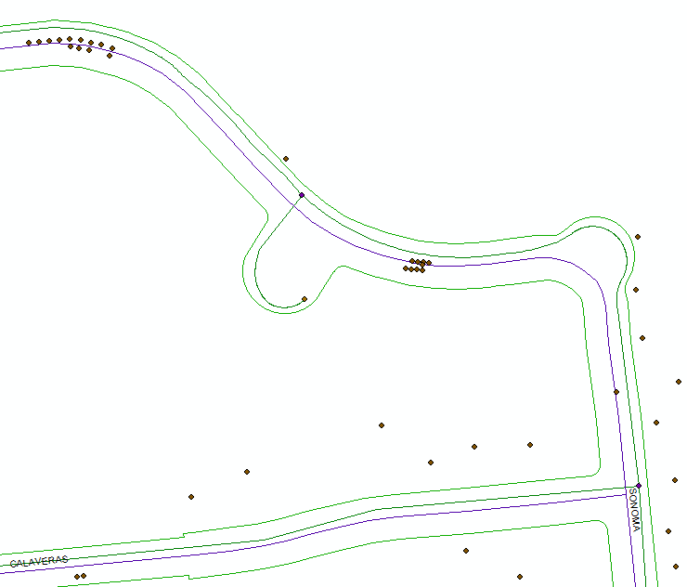
Different feature classes representation in GIS
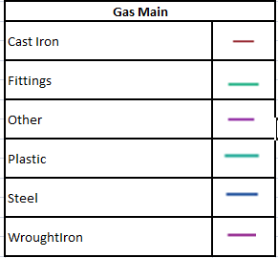 | 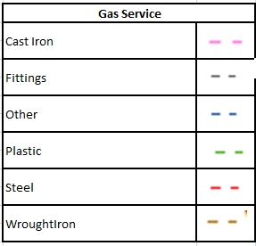
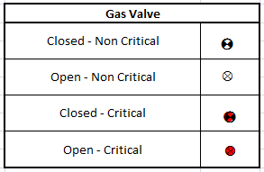   | 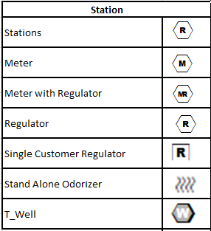
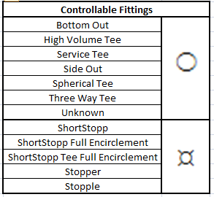  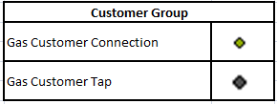 | 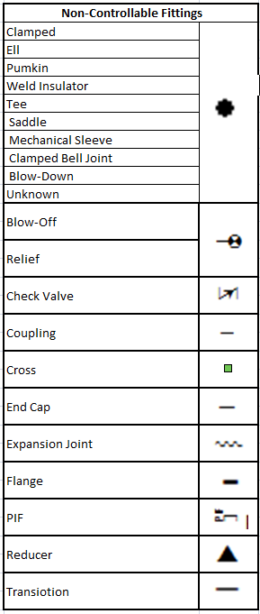

Various symbol standards that may be used on a Service
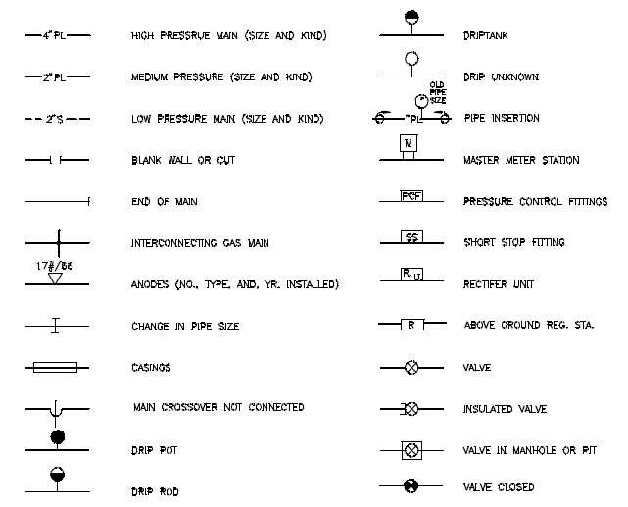
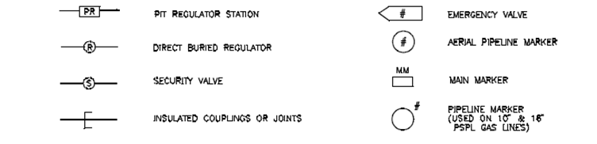
Note: The “Insulated Couplings or Joints” symbol above represents insulation and can apply to other features such as valves. This insulation symbol shall only be considered a coupling if written as such on the service card or if existing GIS already has a coupling placed in the relative position as shown on service card.

PIPE CROSS SYMBOLOGY


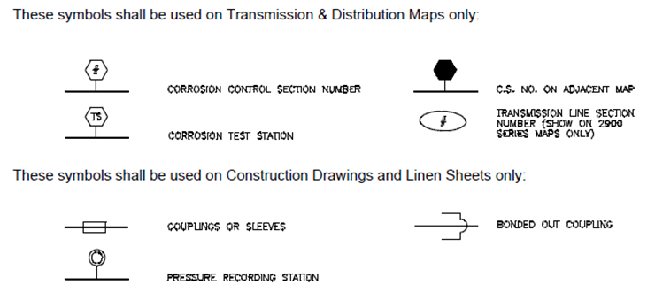
Various Symbols as found on Services
Square or rectangle symbols could be Couplings, Sleeves or Gas Pipe Casings. Place Non Controllable Subtype 23 -Unknown or Gas Pipe Casing as needed. QUESTION (CUSTOMER REFERRAL) if unsure. | 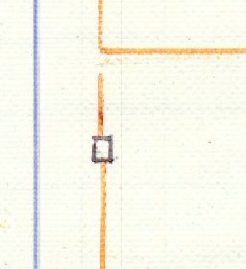
ShortStopp & Transition  (per QUESTION (CUSTOMER REFERRAL) 281) | 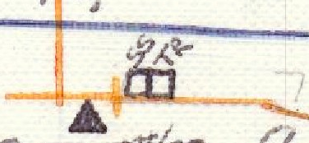
ShortStopp & Transition at Tee Junction is Controllable Three-Way Tee | 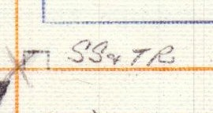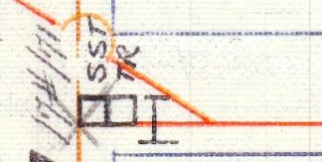  Note: This case there is only 1 transition which is indicated by the TR box, but located where Pipe Change I-beam is drawn.
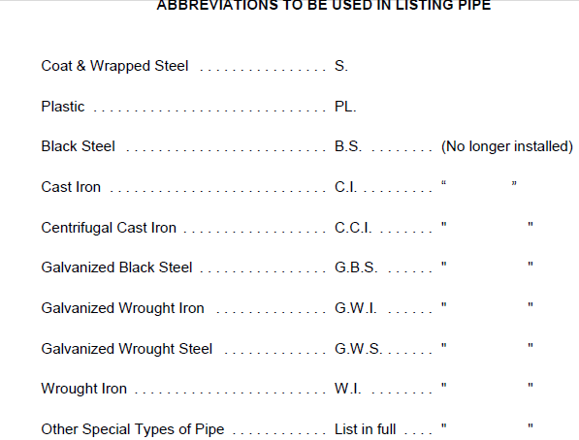
or C/W, C&W
Black Screwed Steel Pipe……………………….BSSP
Black Welded Steel Pipe………………………..BWSP

5.1.3 NIPSCO Terminology
- LOA shall refer to Local Operating Area
- Questions (Customer referral):
  - Send a QUESTION (CUSTOMER REFERRAL) shall refer to the Pinnacle Reporting System

6.0 Index Definitions

6.1 Index Data:

Name (as in XML) | Value List Name | COMMENT | Critical
ADDRESS _NUMBER |  |  | Y
APARTMENT_NUMBER |  |  | Y
CABINET_X0020_NUMBER |  | Please provide in the xml the cabinet number (value)/drawer number (value) the file came from | N (assumption is you are providing this to us for every record)
CITY |  |  | Y
COMMENTS |  |  | N
COUNTY | COUNTY |  | Y
DEVELOPMENT |  | Is not always the same as Subdivision | N
EFV | EFV | EFV Installed | N
GRID_NUMBER |  | Default to what is in the file versus what is on the card. If blank (from file), populate with what is on the card. Leave blank if it's not in the file and not on the card. | N
LOT _NUMBER |  |  | Y
MATERIAL | MATERIAL | aka Pipe Material | Y
OPERATING_AREA |  | aka LOA | Y
PIPE_SIZE | PIPESIZE |  | Y
REGULATOR_INSTALL_DATE |  | Year only, Format = YYYY, Do not use any defaults, if unknown = leave blank | N
RETIRE_DATE |  | Year only, Format = YYYY, Do not use any defaults, if unknown = leave blank | N
SERVICE_RISER_TYPE | RISERTYPE |  | N
RURAL_ROUTE |  |  | Y
SERVICE_TYPE_CODE |  | Default to GAS | Y
SERVICE_INSTALL_DATE |  | Year only, Format = YYYY, Do not use any defaults, if unknown = leave blank | N
SERVICE_LENGTH |  | Pipe Length | Y
SERVICE_NUMBER |  | Site ID (Remove PREMISE from your screen, from the data in the PREMISE field, truncate the first zero and the next 9 are the Site ID, ie, 0224307007-2-0, the proper Site ID is 224307007) | Y
SERVICE_SKETCH | SKETCH | YORN Field | Y
STREET _SUFFIX |  |  | Y
STREET_DIRECTION |  |  | Y
STREET_FRACTION |  |  | Y
STREET_NAME |  |  | Y
STUB | STUB | YORN Field | Y
SUITE |  |  | Y
SUBDIVISION |  | Is not always the same as DEVELOPMENT. If you see numbers on a card, default to what is in the file, if file is blank, leave the field blank. | N
TAX_DISTRICT |  | Value list was already provided | Y
TOWNSHIP | TOWNSHIP | Is not always the same as CITY | Y
ZIP_CODE |  | Currently not displayed to us from your system. Please display. Default to what is in the file. If blank in the file, please populate with what is on the card. | Y

Index Attribute Name | Default Value | Remarks | Critical

Default Values listed in this document should be referenced by Woolpert during the indexing process.

Date Format Standards: If no month or no day, use 01. If only year is given, assume 01-01.

Hour Format Standards: All are based on decimals.

6.2 Universal Assumptions:

- If there are any questions surrounding the clarity of any universal assumption, or any attribute rule/assumption, a customer referral should be created.
- Service card/requests are a point in time snapshot of data and as such should be used by the vendor to Index. NIPSCO, will have the ability to add alternate address information that reflects current address data to aid in user inquiries.
- Index address data should follow USPS standard addressing practices.
- Multiple Index issues (such as a trailer park) that may be resolved by a common solution, the vendor should submit one client referral and add it to the agenda of the weekly QA call.
- GDIP (Gas Distribution Improvement Project) When GDIP is seen on a Gas service card, and if the original material type is not clearly noted, it can be assumed to be plastic. **The rules for Material type still apply even in the case of GDIP. Therefore, if the LONGEST material type noted on the card is something other than plastic, or you cannot determine how much is plastic versus the old material type, then index the material type of the longest length.

6.3 Data not to be captured:
The following list of service cards and/or data not included during the Service Card Index process.
Points:
- Stubs

6.4 Index Data Captured:

6.4.0 General Workflow
- Describe Woolpert work flow here:

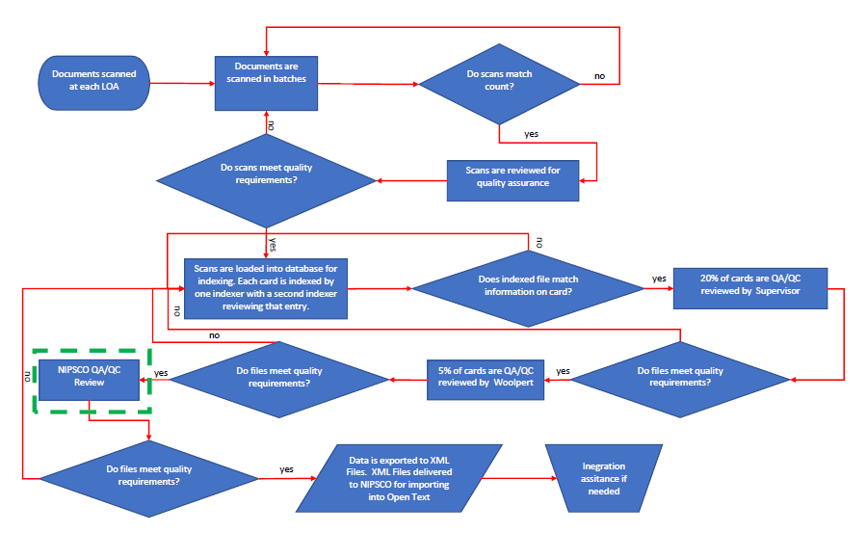
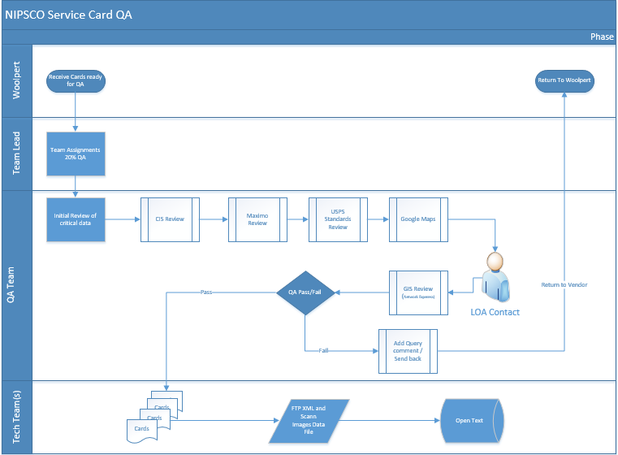

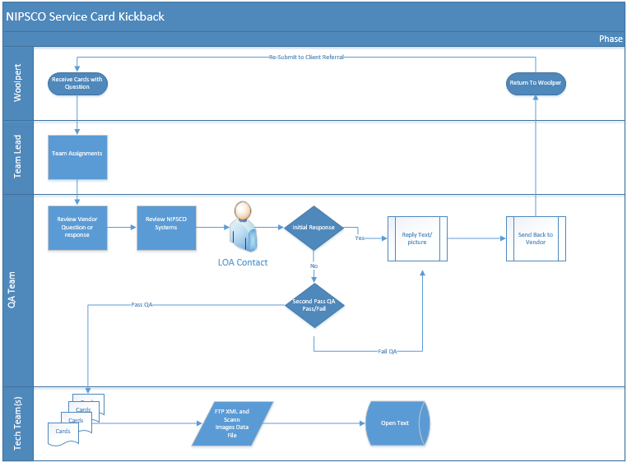

6.4.1 ADDRESS _NUMBER
Indicative of house number, usually precedes a street name. This critical feature is one of the main tools used for locating Service Cards & Service Requests.
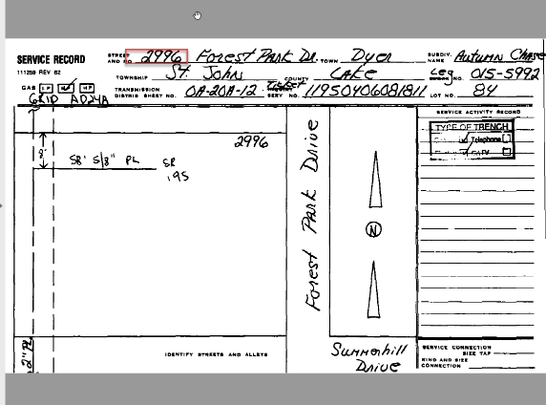

Resources:
- CIS/Maximo/Address File
- Service Card/Service Request
- County GIS Maps

Rules/Assumptions:
- If a Site ID matches between a Service Card/Service Request and on the Address File, but the addresses do not match, default to address file. *If there is an address mistake submit a correction to the CIS team.
- If the address on the Service Card/Service Request matches to a Site ID in the Address File, do not send back to NIPSCO as referral to verify.
- Locate via card before and after missing address number CIS/Maximo
- Locate via Google Maps
- Locate via local County GIS maps
- Alternate addresses will be noted in the Additional Address Fields, and entered by NIPSCO team
- If addresses contain hyphens and it is an exact match in the address file, then use address found in Address File and no need to duplicate record.
- Address range???
- If unable to resolve, leave blank

6.4.2 APARTMENT NUMBER
This attribute contains unique identifying numerals or alpha characters for indicating separate units in a building.

Resources:
- CIS/Maximo/Address File
- Service Card/Service Request

Rules/assumptions:
- Options to resolve for Apt with no site ID: Send back to NIPSCO team
- Options for Apt with Multiple Site ID’s
  - If there are a range of apartment numbers on the card or service request, and each has its own Site ID, then duplicate the card and assign a copy of each card to each site. Relationship = 1:Many
  - If there are a range of apartment numbers on the card or service request and there is only one site ID, then a duplicate card is necessary. Relationship = 1:1

6.4.2 CROSS STREETS
Cross streets will refer to streets closest to a location that intersect near site in question as a geographical point of reference for a site. Cross streets will be utilized to deliver best results for identifying sites according to emergency (911) standards.

Resources:
- Linen Card Viewer/Service Card Viewer/Google Maps/County GIS
- Service Card/Service Request

Rules/assumptions:
- If there is no address on the card, but cross streets and distances are present, vendor should utilize google maps and or county GIS measuring tools to determine a location or property address
- When no address is present and cross streets cannot be identified by the vendor, do not submit the card as a referral to the service card team.
- If there is no address identified on the card and one cannot be identified after the service card team researches the site, service card team will add cross streets in the alternate address fields where available

6.4.2 BUSINESS NAME
This attribute will be added by NIPSCO after receiving the file from Pinnacle. A column will be added to the database and matched via Site ID to populate from the CIS field of DBA (Doing Business As).

6.4.3 CABINET NUMBER
This attribute contains the number indicative of the filing cabinet of which the Service Card was previously stored. This attribute can be utilized for referential purposes. The XML Cabinet Number (Value)/ Drawer (Value) should always be present.
Resources: NA
Rules/assumptions: NA

6.4.4 City
A title representing the city where the gas services exists. Critically important for correctly locating the Service Cards.
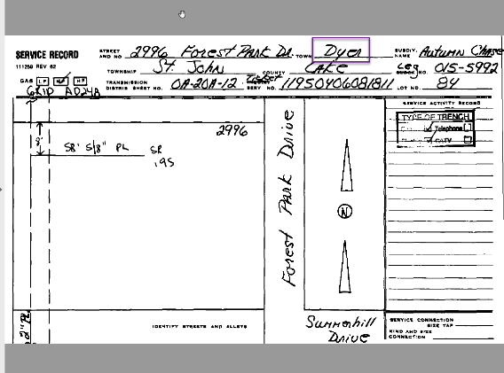

resources:
- CIS/Maximo/Address File
- Value list of known city names and changes
- Service Card/Service Request

Rules/Assumptions:
- If Site ID is on the card and the street address matches, use the City in our address list provided to you
- Check our City Update List - contains list of cities no longer in existence and what their current translation is
- Locate via Google Maps
- Locate via local County GIS maps
- If unable to resolve, submit a query to NIPSCO QA/QC

6.4.5 Comments
Field appearing on Services Cards/Service Requests indicating any additional information. Enter the same text as appears on the Service Card/Service Requests in this field.

resources: NA
Rules/assumptions: NA

6.4.6 County
A name representing the county where the gas service exists. Critically important for correctly locating the Service Cards. Do not assume Cities and Counties are a 1:1 relationship.
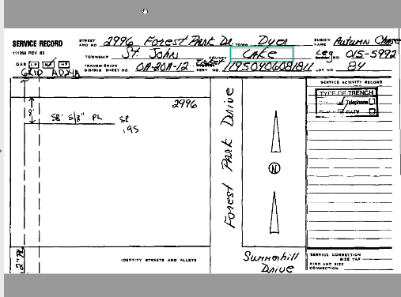

resources:
- Service Card/Service Request
- CIS/Maximo/Address File
Rules/assumptions:
- If Site ID is on the card and the street address matches, use the County in our address list provided to you.
- If there is no Site ID and County is blank, leave blank
- if Site ID is not on card but matches Address File, use the county on the Address File
- Locate via Google Maps
- If unable to resolve, leave blank

Values:

Value | Description
1 | WARREN
10 | BLACKFORD
11 | BOONE
12 | BROWN
13 | CLARK
14 | CLAY
15 | CRAWFORD
16 | DAVIESS
17 | DEARBORN
18 | DECATUR
19 | DELAWARE
2 | WELLS
20 | DUBOIS
21 | FAYETTE
22 | FLOYD
23 | FOUNTAIN
24 | FRANKLIN
25 | GIBSON
26 | GREENE
27 | HAMILTON
28 | HANCOCK
29 | HARRISON
3 | WHITE
30 | HENDRICKS
31 | HENRY
32 | JACKSON
33 | JAY
34 | JEFFERSON
35 | JENNINGS
36 | JOHNSON
37 | KNOX
38 | LAWRENCE
39 | MADISON
4 | WHITLEY
40 | MARION
41 | MARTIN
42 | MONROE
43 | MONTGOMERY
44 | MORGAN
45 | OHIO
46 | ORANGE
47 | OWEN
48 | PARKE
49 | PERRY
5 | CLINTON
50 | PIKE
51 | POSEY
52 | PUTNAM
53 | RANDOLPH
54 | RIPLEY
55 | RUSH
56 | SCOTT
57 | SHELBY
58 | SPENCER
59 | SULLIVAN
6 | GRANT
60 | SWITZERLAND
61 | UNION
62 | VANDERBURGH
63 | VERMILLION
64 | VIGO
65 | WARRICK
66 | WASHINGTON
67 | WAYNE
7 | HOWARD
8 | TIPTON
9 | BARTHOLOMEW
A | ADAMS
B | ALLEN
C | BENTON
D | CARROLL
E | CASS
F | DEKALB
G | ELKHART
H | FULTON
I | HUNTINGTON
J | JASPER
K | KOSCIUSKO
L | LAGRANGE
M | LAKE
N | LAPORTE
P | MARSHALL
Q | MIAMI
R | NEWTON
S | NOBLE
T | PORTER
U | PULASKI
USA | USA
V | ST JOSEPH
W | STARKE
X | STEUBEN
Y | TIPPECANOE
Z | WABASH

6.4.7 Development
A Development is a group of dwellings, trailer park, or apartment houses typically of similar design that are usually built and sold or leased by one management. Development isn’t always the same as the Subdivision.

resources:
- Service Card/Service Record
- CIS/Maximo/Address File

Rules/assumptions:
- If the Service Card/Service Request does not match what is on address file default to what is in the address file.
- If the Service card/Service Request are populated and the address file is blank, use what is on the Service Card/Service Request.
- If both Service Card/Service request is blank and the address file is blank, leave field blank.
- If the name of a Trailer Park is on the Service Card/Service Request add it to the Development field (not the subdivision field). Contractor names leave out.

6.4.8 EFV
Excess Flow Valve (EFV) is a mechanical safety device which stops excess gas from flowing into a gas service line.

resources:
- Service Card/Service Request

Rules/assumptions:
- If only the flow rate is available, default to the value of, Exists.
- If a comparable value cannot be determined, leave field blank. Some comparable values would be Yes= Exists/No= Does not Exist, the presence of a date/numerical value can indicate a valve is present.

Values:

Value | Description
Cannot Determine | Cannot Determine
Does Not Exist | Does Not Exist
Exists | Exists
Retired | Retired
Not Installed | Not Installed
Not Retired | Not Retired
Replaced | Replaced
Installed | Installed

6.4.9 Grid Number
Number of Grid used in dividing land base area. This number is the same as Grid Code.

Resources:
- Service Card/Service Request
- Address File

Rules/assumptions:
- If the Grid Number is not available pull from Address File.
- Leave blank if it’s not in the file and not on the card.

6.4.10 Lot Number
A lot number is an identification number governed by the county assessor to divide plots of land. A lot number can also refer to a number given to a mobile home lot in a mobile home park.
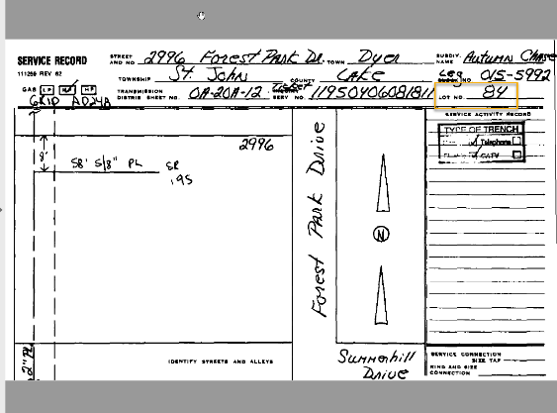

resources:
- GIS County Map
- CIS/Maximo/Address File
- Service Card/Service Request

Rules/assumptions:
- Default to what is in the file versus what is on the card.
- If blank (from file), populate with what is on the card.
- Leave blank if it's not in the file and not on the card.

6.4.11 Material
Material Type represents the material of the service pipe, also known as Pipe Material. See Value List in Appendix.
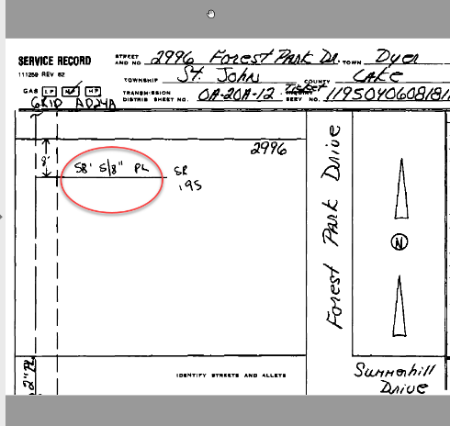

reSOURCES:
- Maximo/Address File
- Service Card/Service Request

Rule/Assumptions:
- Use the value list provided, if a comparable value cannot be determined leave blank.
- If value is present, but cannot be confidently determined send back to NIPSCO.
- In situations where both Plastic & Steel are present on Service Card use the material of the longest length active service segment.
- When GDIP is observed on a card/request - If the original material type is not clearly noted, it can be assumed to be plastic. **The rules for Material type still apply even in the case of GDIP. Therefore, if the LONGEST material type noted on the card is something other than plastic, or you cannot determine how much is plastic versus the old material type, then index the material type of the longest length.
  - When Retired is indicated on GDIP the retired date does not need to be indexed
  - If a completely new service line is installed, mark as “stub” for the retired service line
- When a 5/8” and 1 1/8” pipe size is determined - Material type can be assumed to be “Plastic”
- When a 3/4” and 1 1/4” pipe size is determined - Material type can be assumed to be “Steel” unless otherwise noted on card to be Plastic.
- When a fuel line is reflected in sketch, do not include (as seen in Kokomo)

Values:
Value | Description
Bare Steel | Bare Steel
Steel Treated/Coated | Steel Treated/Coated
Plastic Inserted Into Steel | Plastic Inserted Into Steel
Plastic | Plastic
Iron Wrought/Cast | Iron Wrought/Cast

COATING TYPE TABLE

Year | Listed As | Material
All | Wrought Steel | Steel
Prior to 34 | CI, Cast, Cast Iron | Cast Iron
Prior to 34 | WI, Wrought Iron, | Wrought Iron
Prior to 34 | WS, Black Pipe, BSSP, BWSP, Black Screwed Steel Pipe, Black Welded Steel Pipe, Wrought black pipe | Steel
1934 - 1944 | C&W, Coated and Wrapped, MW, etc. | Steel
1945 - 1959 | C&W, Coated and Wrapped, MW, etc. | Steel
1960 - 1974 | C&W, Coated and Wrapped, MW, etc. | Steel
1974 - 1985 | Epoxy | Steel

6.4.12 Local Operating Area
A NIPSCO operating area that refers to where the service work was completed.

Resources:
- Address File
- CIS/Maximo
Rules:
- LOA’s shall be formatted using a three digit numerical code such as 030
- Always default to LOA in address file
- If no Site ID is available assume LOA from the location from which it was sourced w/ the exception of Angola and Auburn. Send back to NIPSCO for remediation
- If LOA cannot be determined, leave blank and send back to NIPSCO for remediation

6.4.13.0 Main size
Main size refers to the diameter of the main installed
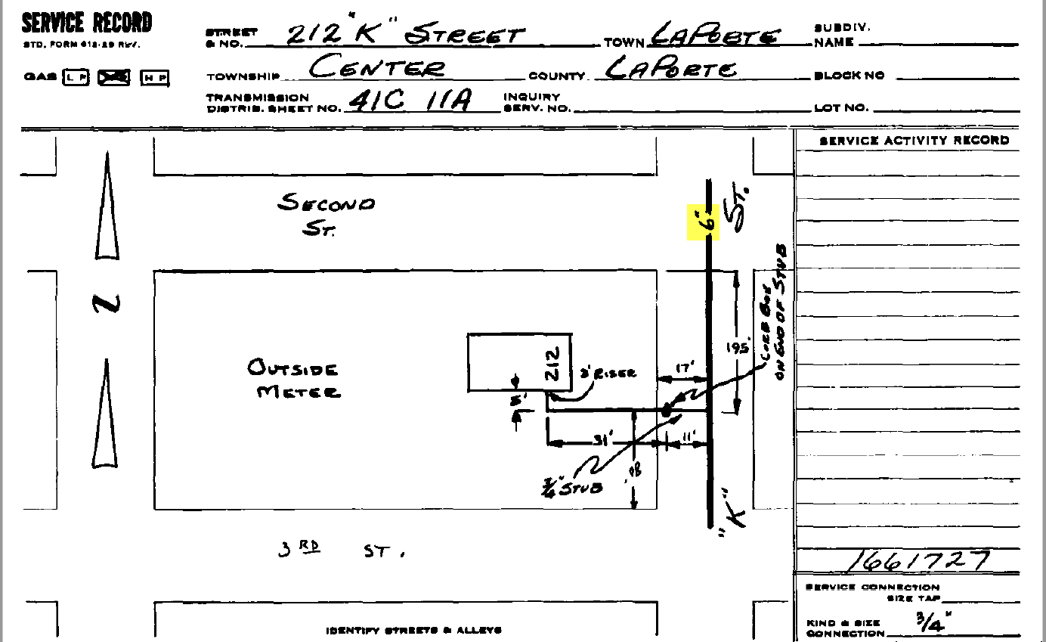
Resources:
- Service Card/Service Request

Rules:
- Use the value provided on the Service Card/Service Request
- If MAIN SIZE cannot be determined via resource listed above, leave blank.
- If there is a Site ID match to the address on Service Card/Service Request, all other pipe information is identified, but the Main size cannot be determined, leave Main Size blank, do not send back referral to NIPSCO
- See Appendix for value list
- Exception: Per Change order dated 7/1/20 Main Size will apply only to the following LOAs: LaPorte, Kokomo, Valparaiso, Goshen, Auburn, Angola, Ft Wayne, Gary

6.4.13.1 Main Material
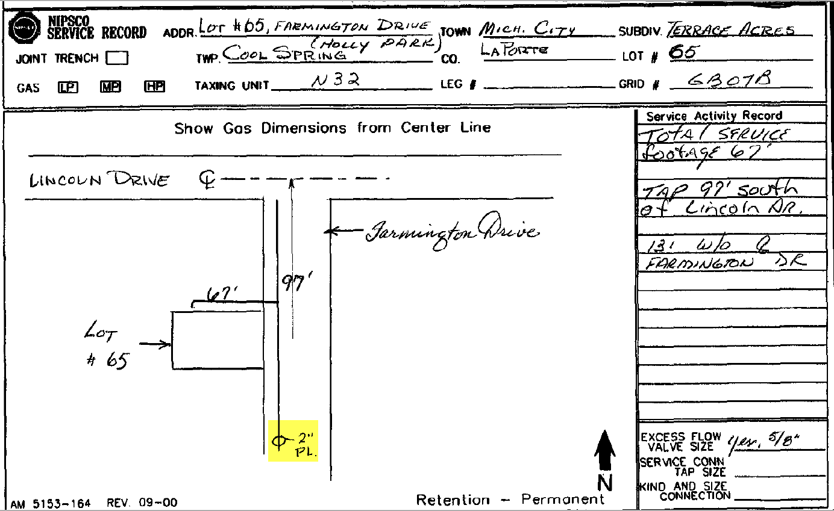
Resources:
- Service Card/Service Request

Rules:
- Use the value provided on the Service Card/Service Request
- If MAIN MATERIAL cannot be determined via resource listed above, leave blank
- If there is a Site ID match to the address on Service Card/Service Request, all other pipe information is identified, but the Main material cannot be determined, leave Main Material blank, do not send back referral to NIPSCO
- If the Service Card/Service Requests reflects Aluminum coating on the main, treat as “steel” but add to the comment section- coated tubing.
- See Appendix for value list
- Exception: Per Change order dated 7/1/20 this will apply only to the following LOAs: LaPorte, Kokomo, Valparaiso, Goshen, Auburn, Angola, Ft Wayne, Gary

6.4.13.2 Pipe size
Pipe size refers to the diameter of the service pipe installed.
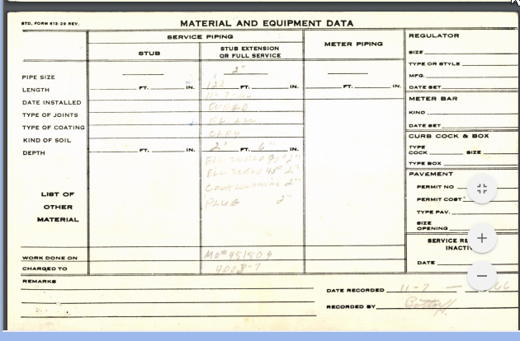
Resources:
- Service Card/Service Request
- Maximo
Rules:
- Use the value provided on the Service Card/Service Request
- If PIPE SIZE cannot be determined via resources listed above, leave blank.
- See Appendix for value list

6.4.14 Regulator Install Date
Regulator install date refers to the date the regulator was installed.
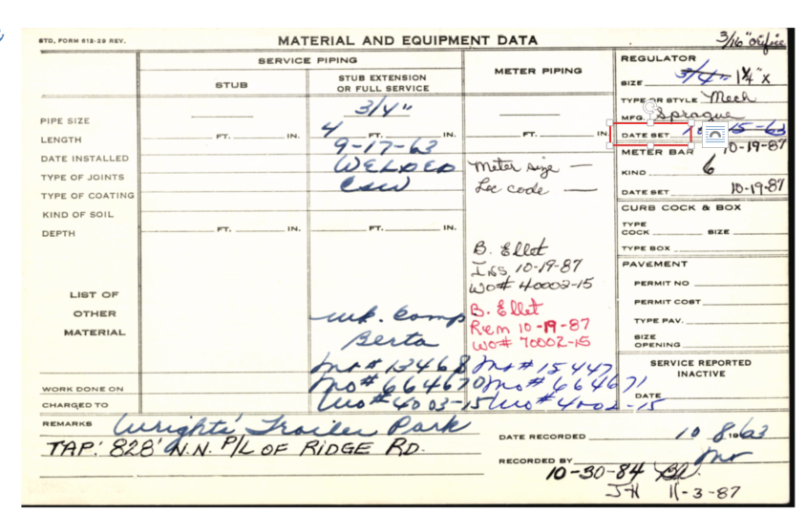
Resources:
- Service Card/Service Request
Rules:
- Use the REGULATOR INSTALL DATE provided on Service Card/Service Request
- Index only the year, using the format equal to YYYY
- If INSTALL DATE is unknown/cannot be clearly determined, leave blank

6.4.15 Retire Date
Retire date refers to the date in which the service line was retired.

Resources:
- Service Card/Service Request
- Maximo
Rules:
- Use the RETIRE DATE provided on SERVICE CARD/SERVICE REQUEST only if the service as fully been retired.
- Index only the year, Format+ YYYY
- If RETIRE DATE is unknown/cannot be clearly determined, LEAVE BLANK
- Do not enter a retired date when a retired date is written on a card, if it is on an active service (has a valid Site Id)

6.4.16 Service Riser Type
Service Riser Type describes the type of riser installed on a service.

Resources:
- Service Card/Service Request
- Maximo
Rules:
- Use RISER TYPE as indicated on Service Card/Service Request
- If value cannot be determined or does not match a value in the value list, LEAVE BLANK
- See DataInformation.xls for value list
- See Service Length- if Riser is more than 3’ add it to the length.

6.4.17 Rural Route
An address used in a rural area as determined by the U.S. Postal Service.

Resources:
- Service Card/Service Request
- Address file/CIS/Maximo
- https://tools.usps.com/zip-code-lookup.htm?byaddress
Rules:
- Use the RURAL ROUTE ADDRESS as indicated on SERVICE CARD/SERVICE REQUEST
- RURAL ROUTE ADDRESSES should be in the following format: RR## BOX###
- *NIPSCO ONLY: If no longer a rural route add modern address in alternate address field

6.4.18 Service Type Code
Type of service going to a building, can be gas or electric. For purposes of this project it will always be “Gas”.
Resources: NA
Rules:

6.4.19 Service Length
The length of the pipe that runs from the main to the meter.
Resources:
- Service Card/ Service Request
- Maximo
Rules:
- Use the SERVICE LENGTH as indicated on the Service Card/Service Request
  - Potential designated locations for this information to be found on the Service Card/Service Request are: comment section, field designated for pipe length, or on card sketch
- This data is to be indexed in numerical format. Use the conversion table supplied in the index to convert fractions to decimal values.
- Where one site id exists for an address, but card reflects multiple service lines that cannot be clearly identified use the longest pipe length
  - When multiple site ID’s exist for a single address this indicates there are multiple meters. Index one length per site ID (if you can’t determine which Site ID goes to which building).
- If SERVICE LENGTH cannot be determined, LEAVE BLANK
- If a drawing reflects a retired line and an active service line, Index the active service length
- If there are multiple lengths of pipe connected, add lengths together and use the sum total as the service length to be indexed
- If the riser is over 3' add it to the service length
- Wall Pipe: Remember, service length is the length of pipe from the main to the meter, the outlet pipe should not be included in the service length.
- If there is *only* a Fuel Line listed, do not include in length, size and type. (as seen in Kokomo)

6.4.20 Service Number/ Site ID
Service Number, aka Site IDs are unique 9-digit number used to identify a gas service to a gas meter. On a Service Card, this can be located by matching the address on the Service Card to the corresponding address in the provided Address File. On a Service Request, it is clearly identified on the ‘Site ID#’ field.

RESOURCES:
- Address File/CIS/Maximo
- Service Card/Service Request

Rule/Assumptions:
- If the Service Card/Service Request does not have a Site ID and there is an address match in the Address File, use the Site ID in the File.
- If there is a mismatch on Site ID between the Service Card/Service Request and the Address File, send an inquiry to NIPSCO QA/QC.
- Address takes precedent over Service Number/Site ID* (edit)
- If the Service Card/Service Request reflects an address and site ID on the card, but does not match the Address File, use the address & sketch information on card.
- If there is no Site ID, check the ‘Stub’ box.
- *Kokomo, Angola, and Auburn Service Cards: In the event that a legacy number is provided on the Service Card, default to the Site ID in the Address File.

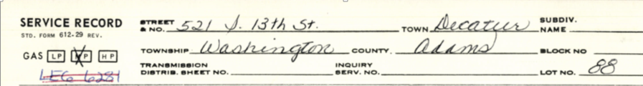

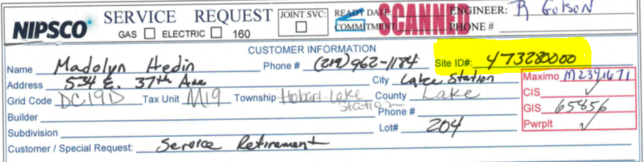

6.4.21 Service Sketch
This field indicates if a sketch is on the Service Card/Service Request.

Valid Sketch

INVALID SKETCH

RESOURCES:
- Service Card/Service Request

Rule/Assumptions:
- If a Service Card/Service Request includes a drawing of the service line from the Main (pipe in the road) to a building, place a check in the sketch box
- If a drawing does NOT include a drawing of the service line from the Main to a building, do not check the sketch box.

6.4.22 Street Suffix
A street suffix follows the name of a street to further describe that street.

RESOURCES:
- Address File/CIS/Maximo
- Service Card/Service Request
- https://tools.usps.com/zip-code-lookup.htm?byaddress
- Google Maps

Rule/Assumptions:
- Enter geographical description (STREET, AVENUE, etc.). Must adhere to USPS Suffix Abbreviations. See Value List in Appendix.

6.4.23 Street Direction
Directional description of the street (i.e. N, E, S, W).

RESOURCES:
- Address File/CIS/Maximo
- Service Card/Service Request
- https://tools.usps.com/zip-code-lookup.htm?byaddress
- Google Maps

Rule/Assumptions:
- Must adhere to USPS Address Standardization rules. See Value List in Appendix.

6.4.24 Street Fraction
All possible fractions are contained within the limits of numeric ranges. Individual fractional addresses should not be coded unless they fall outside of the numeric range or have a different ZIP+4 Code.

Example: If the range is 1–99, 13 1/2, 49 1/3, 57 3/4, and 75 1/16 fall within the limits of the range. 99 1/2 does not, nor does 1/2 or any other purely fractional address.

If a fractional address is the beginning or ending number on the block face, the ZIP+4 file will show a numeric range record and one or more fractional address records that share the same ZIP+4 Code. The address should be ranged to itself (99 1/2–99 1/2 B). If your fractional address needs to carry a different ZIP+4 Code, it must be pulled out of the numeric range as a separate record.

RESOURCES:
- Address File/CIS/Maximo
- Service Card/Service Request
- https://tools.usps.com/zip-code-lookup.htm?byaddress

Rule/Assumptions:
- Enter fraction for address (95 1/2 Main St.).
- Must adhere to USPS Address Standardization rules.

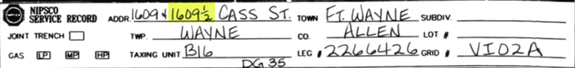

6.4.25 Street Name
The name of the street where the service is located.

RESOURCES:
- Address File/CIS/Maximo
- Service Card/Service Request
- https://tools.usps.com/zip-code-lookup.htm?byaddress
- Google Maps
- County GIS Maps

Rule/Assumptions:
- Enter name of road/street/highway, etc. for address (i.e., Main, Broadway, Center, etc.).
- Typically will be written on the card, if it is not written determine if it can derived from the sketch.
If the street name is derived from the sketch, validate it is the correct street by referencing Google Maps or a County GIS map. This should also match up with an address from the Address File provided. In all cases where the street name is derived, submit an inquiry to NIPSCO QA/QC.

6.4.26 Stub
A Stub is the pipe that is still connected to the Gas Main when a service is retired.

RESOURCES:
- Address File/CIS/Maximo
- Service Card/Service Request

Rule/Assumptions:
- If the Service Card/Service Request indicates this is a stub card, check the ‘Stub’ box.
- If there is an address with no corresponding Site ID, and the address is verified as correct, check the “STUB” box. (NIPSCO will mark as Abandoned in the Site ID field programmatically once we receive the file from Pinnacle.)
- If there is an address with no corresponding Site ID, and address CANNOT be verified as correct, send an inquiry to NIPSCO QA/QC.
- If a drawing indicates an active service line and a retired service line, index the active service line information (ie, length, type, etc), and check the “STUB” box. (This rule is added during Crown Point indexing. NIPSCO understands this data may vary previous to CP indexing.)
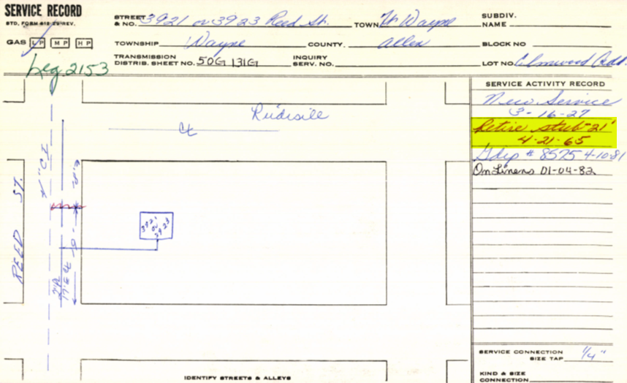
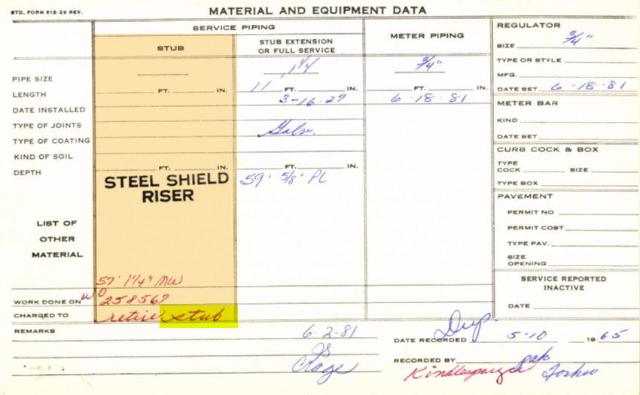

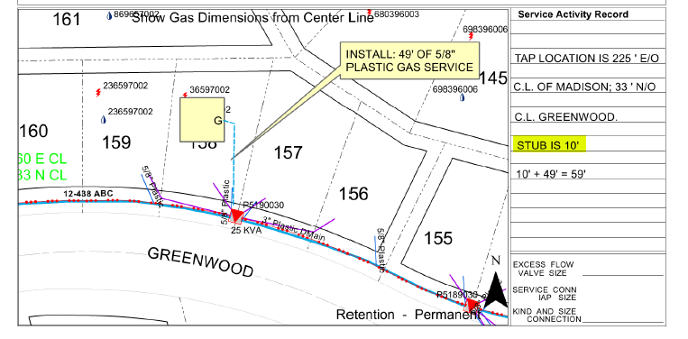

6.4.27 Suite
Suite can also include: Office number, Hanger number, Department number.

RESOURCES:
- Address File/CIS/Maximo
- Service Card/Service Request
- https://tools.usps.com/zip-code-lookup.htm?byaddress
- Google Maps
- County GIS Maps

Rule/Assumptions:
- If no information is provided, leave the field blank.
- Please submit inquiries to NIPSCO QA/QC for verification.

6.4.28 Subdivision
A subdivision is a portion of land divided into lots for real-estate development.

RESOURCES:
- Address File/CIS/Maximo
- Service Card/Service Request

Rule/Assumptions:
- SUBDIVISION is not always the same as DEVELOPMENT.
- If there are numbers in the Subdivision field on a Service Card/Service Request, default to what is in the Address File.
- If both the Service Card/Service Request and the Address File are blank, leave the field blank.
- If there is a valid Subdivision name (not a number) on the card and the Address File is blank, enter the name from the card.

6.4.29 Tax District
An area, geographically, with the same calculations for tax.

RESOURCES:
- Address File/CIS/Maximo
- Service Card/Service Request

Rule/Assumptions:
- Default to what is provided in the Address File when it is different from what is on the Service Card/Service Request.
- If no Tax District is provided, leave the field blank.

6.4.30 Township
A unit of local government, usually a subdivision of a county.

RESOURCES:
- Address File/CIS/Maximo
- Service Card/Service Request

Rule/Assumptions:
- TOWNSHIP is not always the same as CITY.
- Populate the township with the value, not the description, in the TOWNSHIP Value List. See Value List in Appendix.
- If the township information in the Address File is different from the township listed on SC/SR, default to township in the Address File.

6.4.31 Zip Code
A group of five or nine numbers that are added to a postal address to assist the sorting of mail.

RESOURCES:
- Address File/CIS/Maximo
- Service Card/Service Request

Rule/Assumptions:
- Default to what is in the Address File. If Address File is blank, populate with what is on the card.
- If Service Card/Service Request has no Site ID, has no address that can be correctly identified, card should be stubbed and only index what is on the card. If the card does not have a zip code leave it blank.

6.4.32 Install Date
Resources:
- Service Card/Service Request

Rules:
- Use the INSTALL DATE provided on Service Card/Service Request
- Index using the format equal to MYYYY
- If INSTALL DATE is unknown/cannot be clearly determined, leave blank
- If there are multiple install dates, Index the most recent date
- Where one site id exists, but card reflects multiple service lines or material types the longest active service line is to be indexed using its material and install date

6.5 NIPSCO Standards for Gas Network:

6.5.1 Standard Pipe Sizes for Gas Main and Service Line
Note: The Casing Sizes in this table will only be used if a Casing Size is not listed on the source service card.

Value | Description
0 | Unknown
0.5 | 1/2"
0.625 | 5/8"
0.375 | 3/8"
0.75 | 3/4"
1 | 1"
1.125 | 1 1/8"
1.25 | 1 1/4"
1.5 | 1 1/2"
2 | 2"
3 | 3"
4 | 4"
6 | 6"
8 | 8"
10 | 10"
12 | 12"
14 | 14"
16 | 16"
18 | 18"
20 | 20"
22 | 22"
24 | 24"
30 | 30"
36 | 36"

 | Controllable Fittings by Subtype
Fitting Sizes | Short Stopp | Three Way Tee | Stopper | Spherical Tee | Service Tee*** |  | High Volume Tee** | Stopple | Bottom Out
Fitting Sizes | METAL | METAL | METAL | METAL | METAL | PL* | PL | METAL | METAL
1/2" |  |  | x |  | x
3/4" | x |  | x |  | x
1” |  |  |  |  | x
1-1/4" | x |  | x |  | x
2" | x | x | x | x | x |  | x |  | x
3" | x | x | x | x |  |  | x |  | x
4" | x | x | x | x |  |  | x | x | x
6" | x | x | x | x |  |  | x | x | x
8" | x | x | x | x |  |  | x | x | x
10" | x | x | x | x |  |  |  | x | x
12" | x | x | x | x |  |  |  | x | x
12 x 10 |  |  |  | x
*Plastic Service Tees are installed with the size of the main x 1 (reference table above)
**High Volume Tees are installed the size IS 2” X main” (reference table above)
***Service Tees are used by Woolpert for Single Customer Reg Stations only

Note: For Unknown Controllable Fittings, the sizes such as 4x2 and 8x6 can be used when there is a null date and so the single size is unknown. NIPSCO records the size of the newest mains on Controllable Fittings that are not Unknown (Subtype 23). Woolpert will record what is listed on the service card.

10.0 Appendices

10.0.1 Postal Service Standard Suffix Abbreviation
Primary Street Suffix Name | Postal Service Standard Suffix Abbreviation
ALLEY | ALY
ANEX | ANX
ARCADE | ARC
AVENUE | AVE
BAYOU | BYU
BEACH | BCH
BEND | BND
BLUFF | BLF
BLUFFS | BLFS
BOTTOM | BTM
BOULEVARD | BLVD
BRANCH | BR
BRIDGE | BRG
BROOK | BRK
BROOKS | BRKS
BURG | BG
BURGS | BGS
BYPASS | BYP
CAMP | CP
CANYON | CYN
CAPE | CPE
CAUSEWAY | CSWY
CENTER | CTR
CENTERS | CTRS
CIRCLE | CIR
CIRCLES | CIRS
CLIFF | CLF
CLIFFS | CLFS
CLUB | CLB
COMMON | CMN
COMMONS | CMNS
CORNER | COR
See Street Suffix tab in the Address File for full list.
10.0.1 Postal Service Standard Directional Abbreviation
Postal Service Standard Directional Name | Postal Service Standard Directional Abbreviation
NORTH | N
NORTHEAST | NE
EAST | E
SOUTHEAST | SE
SOUTH | S
SOUTHWEST | SW
WEST | W
NORTHWEST | NW

10.0.2 Tax District
See Tax District tab in the Address File.

10.0.3 Townships
See Townships tab in the Address File.

10.0.4 Campus (Hospital, School, Industrial, etc)
When indexing any campus which has multiple buildings (that may or may not have a physical street address), if a building name or number is indicated on the Service Card or Service Request, index it in the Building field. An assumption is this location has a Site ID.
10.0.5 Damaged Cards and Attachments
If a service sketch and / or an address are present, check the card before and after the damaged card. Some cards have attachments and may be in the form of a scrap piece of paper, an index card, a post-it note, etc. These must be matched to the proper card when possible as often they contain importation information related to the service. It is not necessary to submit this for a referral if you have resolved the attachment /damaged card to a Site ID.
If you come across a card which is damaged and there is no sketch and no address, mark as STUB. It is not necessary to submit this for a referral.
Both instances above will then flow into the normal QA process.

11.0 Retired Cards

11.0.1 How to index a Fully Retired Service
- Determine card represents a fully retired service. The scenarios below depict ways to identify a fully retired service. The scenarios are independent of each other.
  - Card found in a drawer labeled as Retired AND the address does NOT match to a valid Site ID
  - Card found in a drawer NOT labeled as Retired, has Retired written on the card, AND drawing shows no service lines in service (is crossed out, marked in red, etc)
  - Card found in a drawer NOT labeled as Retired, does not have Retired written on the card, but drawing shows no service lines in service (is crossed out, marked in red, etc)
- Index the Above Scenarios with the Following Information
  - Any address information available on the card
  - No measurements
  - Mark as STUB
  - Service Type = GAS
  - Do not send to NIPSCO as a referral

12.0 Scenarios that should not be returned as referrals
  - Service Length cannot be determined (for those cards with a Site ID match)
    - Leave it blank and do not send as a referral
    - No Site ID match
    - If there is no address, no cross roads (either in the address field or on the sketch), no Lot#, no Suite#, and no Bldg# to help identify the location
    - Then place an address description as best you can from the card, stub it, do not document the measurements, and do not send as a referral
    - Fully retired service (see Retired section)

12.0.1 Examples of cards not to send as Referral to NIPSCO
